NBKRIST
ELECTROMECHANICAL ENERGY CONVERSION – III
LECTURE NOTES
UNIT-4
DEPARTMENT OF ELECTRICAL AND ELECTRONICS ENGINEERING

UNIT-IV
Parallel operation of alternators: Conditions for parallel operation-synchronization - load sharing - synchronizing power-operation on infinite bus bar-effect of change of excitation - effect of change of mechanical input - excitation systems.

Parallel Operation of Alternator

Why Parallel Operation of Alternators?
- Several alternators can supply a bigger load than a single alternator.
- One or more alternators may shut down during the period of light loads. Thus, the remaining alternator operates at near or full load with greater efficiency.
- When one machine is taken out of service for its scheduled maintenance and inspection, the remaining machines maintain the continuity of the supply.
- If there is a breakdown of the generator, there is no interruption of the power supply.
- Number of machines can be added without disturbing the initial installation according to the requirement to fulfil the increasing future demand of the load.
- Parallel operation of the alternator, reduces the operating cost and the cost of energy generation.
- It ensures the greater security of supply and enables overall economic generation.
The conditions to be satisfied for parallel operation of the alternator are
- The phase sequence of the incoming machine voltage and the bus bar voltage should be identical.
- The RMS line voltage (terminal voltage) of the bus bar or already running machine and the incoming machine should be the same.
- The phase angle of the two systems should be equal.
- The frequency of the two terminal voltages (incoming machine and the bus bar) should be nearly the same. Large power transients will occur when frequencies are not nearly equal.

Generator Synchronization
A stationary generator must not be connected to live Bus bars because the induced EMF is zero at standstill, resulting in a short circuit. The Synchronisation procedure and the equipment for checking it are the same whether one alternator is to be connected in parallel with another alternator, or an alternator is to be connected to the infinite bus.
The following methods are used for synchronisation.
Synchronisation by synchronising lamps
A set of three synchronising lamps can be used to check the conditions for paralleling or synchronisation of the incoming machine with the other machine. A dark lamp method along with a voltmeter used for synchronising is shown below fig.4.1. This method is used for low power machine.
The prime mover of the incoming machine is started and brought nearer to its rated speed. A field current of the incoming machine is adjusted in such a way so that it becomes equal to the bus voltage. The flicker of the three lamps occurs at a rate which is equal to the difference in the frequencies of the incoming machine and the bus. All the lamps will glow and off at the same time if the phases are properly connected. If this condition does not satisfy, then the phase sequence is not connected correctly.
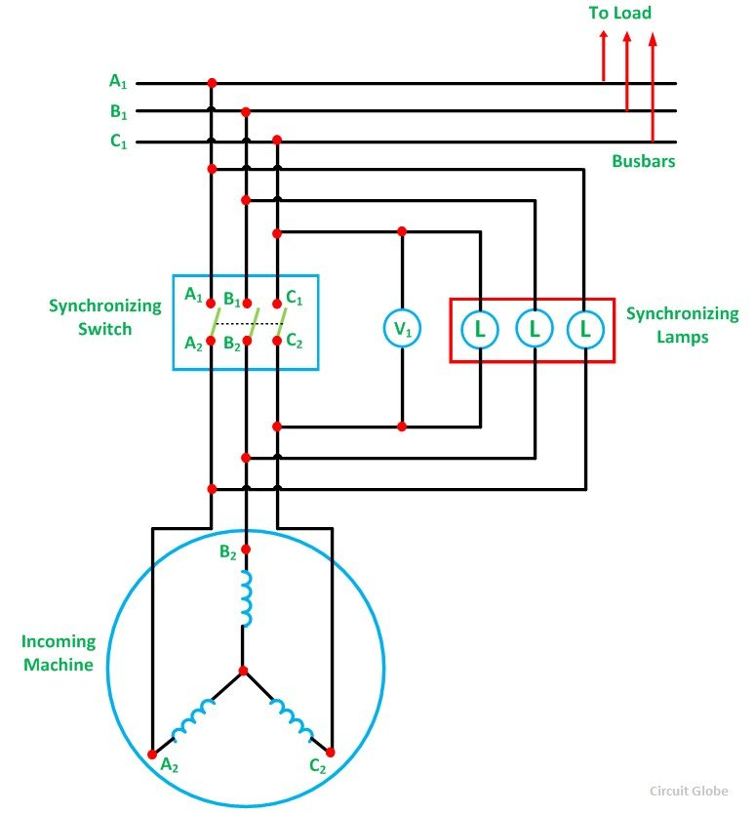
Figure 4.1
Thus, in order to connect the machine in the correct phase sequence, two leads to the line of the incoming machine should be interchanged. The frequency of the incoming machine is adjusted until the lamp flicker at a slow rate. The flicker rate should be less than one dark period per second. After finally adjusting the incoming voltage, the synchronising switch is closed in the middle of their dark period.

Advantages of the Dark Lamp Method
- This method is cheaper.
- The correct phase sequence is easily determined.

Disadvantages of the Dark Lamp Method
- The lamp becomes dark at about half of its rated voltage. Hence, it is possible that the synchronizing switch might be switched off even when there is a phase difference between the machines.
- The filament of the lamp might burn out.
- The flicker of the lamps does not indicate that which lamp has the higher frequency.

Three Bright Lamp Method
In this method, the lamps are connected across the phases such as A₁ is connected to B₂, B₁ is connected to C₂ and C₁ is connected to A₂. If all the three lamps get bright and dark together, this means that the phase sequence is correct. The correct instant of closing the synchronising switch is in the middle of the bright period.

Two Bright One Dark Lamp Method
In this method, one lamp is connected between corresponding phases while the two others are cross-connected between the other two phases as shown in the fig. 4.2 below.
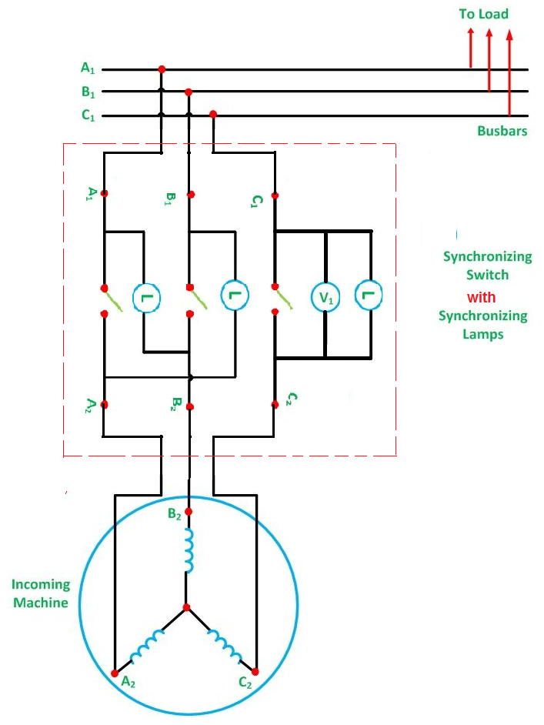
Figure 4.2
Here, A₁ is connected to B₂, B₁ to A₂ and C₁ to C₂. The prime mover of the incoming machine is started and brought up to its rated speed. The excitation of the incoming machine is adjusted in such a way that the incoming machine induces the voltage E_{A1}, E_{B2}, E_{C3}, which is equal to the Bus bar voltages V_{A1}, V_{B1} and V_{C1}. The diagram is shown below fig. 4.3.
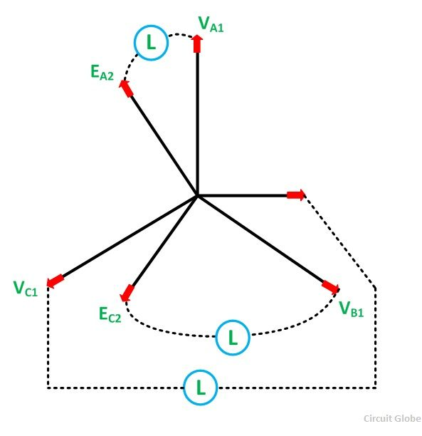
Figure 4.3
The correct moment to close the switch is obtained at the instant when the straight connected lamp is dark, and the connected cross lamps are equally bright. If the phase sequence is incorrect, no such instant will take place, and all the lamps will be dark simultaneously.
The direction of rotation of the incoming machine is changed by interchanging the two lines of the machine. Since the dark range of the lamp extends to a considerable voltage range, a voltmeter V₁ is connected across the straight lamp. The synchronising switch is closed when the voltmeter reading is zero.
Thus, the incoming machine is now floating on the Bus bar and is ready to take up the load as a generator. If the prime mover is disconnected, it behaves as a motor. For paralleling small machines in power stations, three lamps along with the synchroscope are used. For synchronising very large machine in power stations, the whole procedure is performed automatically by the computer.

Synchroscope Synchronizing

Synchroscope compares the voltage from one phase/between two lines of the incoming machine with the phase of the three phase system. The phase sequence of the generator is usually checked carefully at the time of its installation. The fig. 4.4 is shows the circuit diagram for synchronization of Synchroscope method..
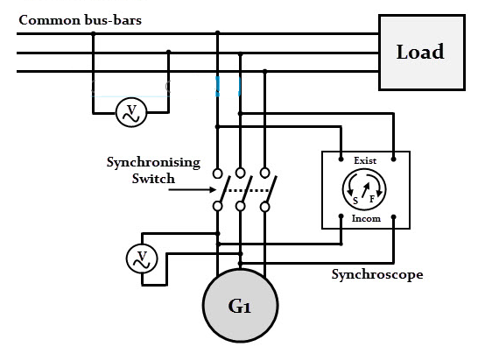
Figure 4.4
The position of a pointer of the Synchroscope shows the phase difference between the voltages of the incoming machine and the infinite bus. When the frequencies are equal, the pointer is stationary. When the frequencies differ, the pointer rotates in one direction or the other. The direction of motion of the pointer shows whether the incoming machine is running too fast or too slow. This means that whether the frequency of the incoming machine is higher or lower in comparison to the infinite bus.
The frequency and phase positions are controlled by adjusting the prime mover input of the incoming machine.
When the indicator of the Synchroscope moves very slowly and passes through the zero phase point or vertical up position, the circuit breaker is closed, and the incoming alternator is connected to the bus. In this case, the frequencies are almost the same. The Synchroscope checks the relationships only on one phase and does not give any information about phase sequence.

Load Sharing
When several alternators are required to run in parallel, it probably happens that their rated outputs differ. In such cases it is usual to divide the total load between them in such a way that each alternator takes the load in the same proportion of its rated load in total rated outputs. The total load is not divided equally. Alternatively, it may be desired to run one large alternator permanently on full load, the fluctuations in load being borne by one or more of the others. If the alternators are sharing the load equally the power triangles are as shown in Fig. 4.5.
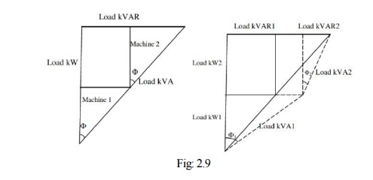
Fig. 4.5

Sharing of load when two alternators are in parallel
Consider two alternators with identical speed load characteristics connected in parallel as shown in Fig. 4.6.
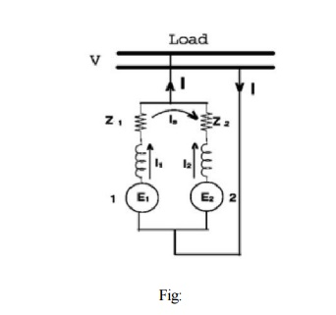
Fig. 4.6

Let E₁, E₂ be the induced emf per phase,
Z₁, Z₂ be the impedances per phase,
I₁, I₂ be the current supplied by each machine per phase
Z be the load impedance per phase,
V be the terminal voltage per phase
From the circuit we have, V = E₁ - I₁Z₁ = E₂ - I₂Z₂ and hence,
I₁ = E₁ - V/Z₁ and I₂ = E₂ - V/Z₂ and also V = (I₁ + I₂) Z = IZ
Solving above equations
I₁ = [(E₁- E₂) Z + E₁ Z₂]/ [Z (Z₁ + Z₂) + Z₁Z₂]
I₂ = [(E₂- E₁) Z + E₂ Z₁]/ [Z (Z₁ + Z₂) + Z₁Z₂]
The total current, I = I₁ + I₂ = [E₁Z₂ + E₂Z₁] / [Z (Z₁ + Z₂) + Z₁Z₂]
And the circulating current or synchronizing current, I_{s} = (E₁ - E₂) / (Z₁ + Z₂)

Synchronizing Power and Torque Coefficient
Definition: – Synchronizing Power is defined as the varying of the synchronous power P on varying in the load angle δ. It is also called Stiffness of Coupling, Stability or Rigidity factor. It is represented as P_{syn}.
Consider a synchronous generator synchronised with infinite bus and transferring a steady power P_{a} at a steady load angle δ₀. Suppose that, due to a transient disturbance, the rotor of the generator may accelerate/decelerate, resulting from an increase/decrease in the load angle by dδ. The operating point of the machine shifts to a new constant power line and the load on the machine increase/decrease to P_{a} ± δP. The steady power input of the machine does not change and due to this the generator may come out from synchronism. To maintain generator in synchronism the speed of the generator will be decrease/increase by adding/removing the load on the generator.
The effectiveness of this correcting action depends on the change in power transfer for a given change in load angle. The measure of effectiveness is given by Synchronising Power Coefficient.
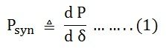
Power output per phase of the cylindrical rotor generator
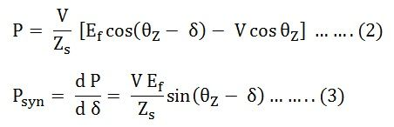
The synchronising torque coefficient
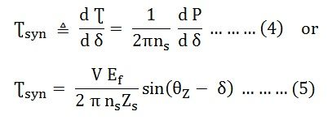
In many synchronous machines, Xs >> R. Therefore, for a cylindrical rotor machine, neglecting saturation and stator resistance equation (3) and (5) becomes
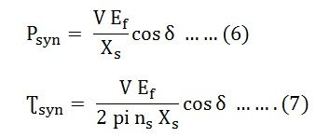
For a salient pole machine
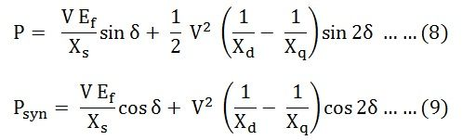

Unit of Synchronizing Power Coefficient P_{syn}
The synchronising Power Coefficient is expressed in watts per electrical radian.
Therefore,
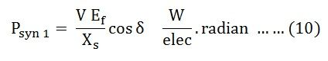
Since, π radians = 180⁰
1 radian = 180/π degrees
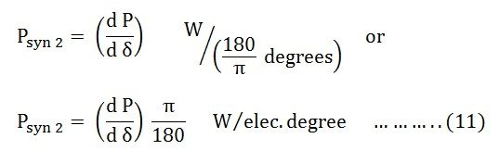
If P is the total number of pair of poles of the machine.
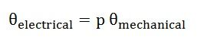
Synchronising Power Coefficient per mechanical radian is given by the equation shown below.
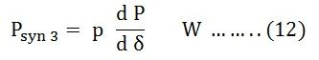
Synchronising Power Coefficient per mechanical degree is given as
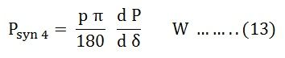

Synchronizing Torque Coefficient
Synchronising Torque Coefficient gives rise to the synchronising torque coefficient at synchronous speed. That is, the Synchronizing Torque is the torque which at synchronous speed gives the synchronising power.
If Ʈ_{syn} is the synchronising torque coefficient, then the equation is given as shown below.
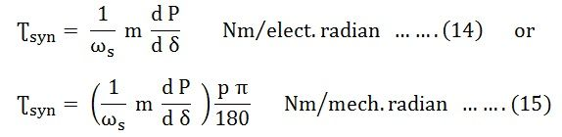
Where,
- m is the number of phases of the machine
- ω_{s} = 2 π n_{s}
- n_{s} is the synchronous speed in revolution per second
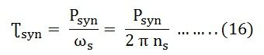

Significance of Synchronous Power Coefficient
The Synchronous Power Coefficient P_{syn} is the measure of the stiffness between the rotor and the stator coupling. A large value of P_{syn} indicates that the coupling is stiff or rigid. Too rigid a coupling means and the machine will be subjected to shock, with the change of load or supply. These shocks may damage the rotor or the windings. We have,
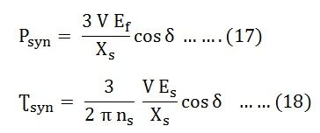
The above two equations (17) and (18) show that P_{syn} is inversely proportional to the synchronous reactance. A machine with large air gaps has relatively small reactance. The synchronous machine with the larger air gap is stiffer than a machine with a smaller air gap. Since P_{syn} is directly proportional to E_{f}, an overexcited machine is stiffer than an under the excited machine.
The restoring action is great when δ = 0, that is at no load. When the value of δ = ± 90⁰, the restoring action is zero. At this condition, the machine is in unstable equilibrium and at steady state limit of stability. Therefore, it is impossible to run a machine at the steady state limit od stability since its ability to resist small changes is zero unless the machine provided with special fast acting excitation system.

Infinite Bus
A system having a constant voltage and constant frequency regardless of the load is called an Infinite Bus bar system. Thus, an infinite bus has a large power system. The amount of real and reactive power is drawn or supplied, does not affect its voltage and frequency. They both remain constant.
In a power system, normally more than one alternator operates in parallel. The machine may be located at different places. A group of machines located in one place may be treated as a single large machine. The machine connected to the same bus, but separated by transmission lines of low reactance, may be grouped into one large machine.
The system behaves like a large generator having internal impedance zero and infinite rotational inertia.

Characteristics of an Infinite Bus
The characteristics of an infinite bus are as follows:-
- The terminal voltage remains constant because the incoming machine is too small to increase or decrease the voltage.
- The frequency remains constant as the rotational inertia is too large to enable the incoming machine to alter the speed of the system.
- The synchronous impedance is very small since the system has a large number of alternator in parallel.
The behaviour of a synchronous machine on an Infinite Bus is quite different from its isolated operation because the steady state speed is fixed at a value corresponding to the line frequency. In an isolated operation, the change of excitation changes its terminal voltage. The power factor depends on the load only.
When the alternator is working in parallel with an infinite bus and its excitation is changed the power factor of the machine changes. However, the change of excitation does not change the terminal voltage, and it remains constant.

Operating Characteristics of an Infinite Bus
An alternator connected to an infinite bus has the following operating characteristics.
- The system to which the alternator is connected controls its terminal voltage and frequency.
- The governor set points of the alternator control the real power supplied by the alternator to the infinite bus.
- The field excitation current in the alternator controls the reactive power supplied by the alternator to the infinite bus. Increasing the field current in the alternator operating in parallel with an infinite bus increases the reactive power output of the alternator.

Obtaining an Infinite Bus
Consider generators G₁, G₂, G₃……G_{n} connected to an infinite bus as shown in the fig. 4.5 below.
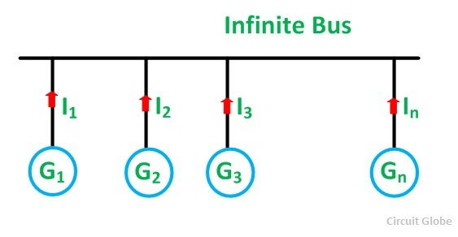
Figure 4.5
Proof of Voltage Remaining Constant
Let,
- V be the terminal voltage of the bus
- E be the induced emf of each generator
- Z_{S} is the synchronous impedance of each generator
- n is the number of generators in parallel
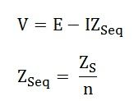
When n is very large Z_{Seq} → 0 and, therefore, I Z_{Seq} → 0
Therefore, V = E (constant)
If the number of alternators operating in parallel is infinite only then Z_{S} = 0
Proof of Frequency Remaining Constant
Let,
- J be the moment of inertia of each alternator
Total moment of inertia of all n alternators is given as
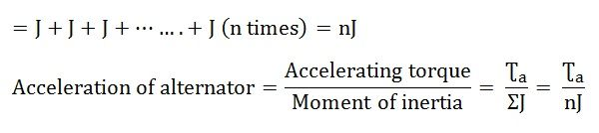
If the value of n is very large, nJ is also very large.
Therefore, acceleration → 0 and the speed is constant.
Therefore, the number of alternators connected in parallel should be as large as possible in order to obtain a constant voltage and frequency of a practical Busbar system.

Alternators Connected to Infinite Bus bar
In the previous post we have seen that synchronous generators do not operate individually in a generating station but they are interconnected so that total generating capacity will be high. When number of alternators are interconnected forming a system which may be treated as an infinite bus. Infinite bus bar is one which keeps constant voltage and frequency although the load varies. Thus it may behave like a voltage source with zero internal impedance and infinite rotational inertia. Any alternator switched on to or off, the infinite bus does not cause any change in the voltage and frequency of the system.
The characteristics of a synchronous generator on infinite bus bars are quite different from those when it is connected to another alternator and both are in parallel. When two alternators are connected in parallel we have seen that a change in the excitation changes the terminal voltage and p.f. is determined by load. However change in excitation for an alternator connected to infinite bus bar will not change the terminal voltage but the power factor only is affected whereas the power developed by an alternator depends only on mechanical power input.
Now we will consider the effect of excitation and driving torque on the performance of an alternator which is connected to infinite bus bar. In all the further discussion we will take zero losses for the machine.
Effect of Excitation
Let us consider the cylindrical rotor as shown in the Fig.4.6 connected to infinite busbar.
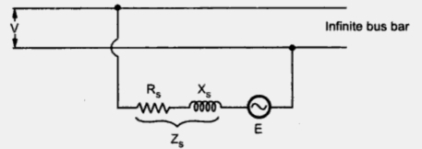
Figure 4.6
The voltage equation can be written as
where E = Induced e.m.f. or excitation e.m.f.
V = Constant bus voltage
I = Armature current
Z_{s} = Synchronous impedance
The same equation neglecting the armature resistance can be rewritten as,
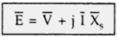
Again we will consider the two cases one with alternator on no load and other with alternator on load.
Alternator on No Load
Since we are considering the losses to be zero the power angle will be zero. Thus the power transferred from or to the bus is zero (P = ((EV/X_{s}) sinδ)
Now if the excitation is properly adjusted at no load then induced e.m.f. E will be equal to bus voltage V and no current will flow. This is shown in Fig. 4.6. This is floating condition of alternator.
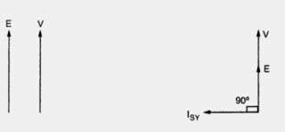
Figure 4.6 Figure 4.7
Now if the alternator is under excited then induced e.m.f. E will be less that V. This will cause circulating current I_{SY} to flow which will lead E by angle of 90º. Due to this it produces magnetizing m.m.f. which will try to increase field m.m.f. to maintain alternator terminal voltage equal to the bus bar voltage. This is shown in the following Fig. 4.7.
Similarly if alternator is over excited then induced e.m.f. will be more than V which will again cause a circulating current to I_{SY} flow. The power angle δ is zero. This current lags E by 90º. This will produce demagnetizing armature m.m.f. which will counterbalance the effect of increased field m.m.f. and again the terminal voltage of an alternator will be equal to constant bus bar voltage V. This is represented in Fig. 4.8.
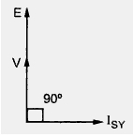
Figure 4.8
It can be seen that in both the cases considered above, no active power is delivered since I_{SY} is in quadrature with V and load angle is also zero. But alternator takes reactive power from bus since E < V and delivers it to bus if E > V.
Alternator on Load
Now let us consider that alternator is supplying power to an infinite bus which has induced e.m.f. E, power angle δ and working at unity power factor with current I.
With mechanical power input to the alternator remaining constant, the power given by (EV/X_{s}) sin δ will remain constant. If by varying excitation induced e.m.f. E is increased to E₁ then the load angle will also change from δ to δ₁. From the phasor diagram it can be determined as E₁ sinδ₁ = E sinδ as V and X_{s} are constant. The drop due to synchronous reactance also increases and armature current increases from I to I₁. This current has two components one real component and other quadrature component. This quadrature component is nothing but demagnetizing component. This will result in lagging power factor cosΦ₁.
Similarly if the excitation is decreased so that induced e.m.f. reduces from E to E₂ with corresponding change in power angle from δ to δ₂. The armature current in this case will be I₂ which has real component and magnetizing component which results in leading power factor cosΦ₂. This can be represented in the phasor diagram shown in Fig. 4.9.
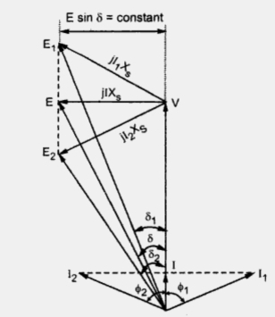
Figure 4.9
From the phasor diagram it can be seen that
I₁ cosΦ₁ = I₂ cosΦ₂ = 1
Multiplying by V throughout,
V I₁ cosΦ₁ = V I₂ cosΦ₂ = VI
This indicates that power delivered to the bus will remain constant. Thus by changing the field excitation the active power is unaltered. But change in excitation results in corresponding operating power factor as shown in phasor diagram.
Note: An under excited alternator operates at leading power factor whereas an over excited alternator operates at lagging power factor.
It can also be seen that armature current is minimum at unity power factor. For over excited alternator as E₁ cos δ >V therefore as seen from case (i) i.e. no load condition alternator delivers reactive power to the bus whereas for under excited alternator E₂ cosδ < V, alternators takes reactive power from the bus. This variation of excitation and armature current can be plotted as shown in Fig. 4.10. This is known as curves for synchronous generators by virtue of their shape.
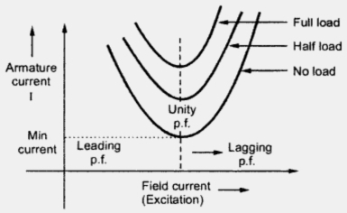
Figure 4.10
Effect of Driving Torque
As already discussed in the previous section the driving torque of an alternator can be changed by throttle opening in steam power plants and by gate opening in case of hydro generation. Let us see the effect of driving torque on performance of alternator with the help of phasor diagram as shown in Fig. 4.11.
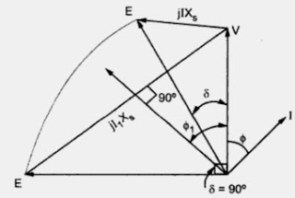
Figure 4.11
The voltage equation remains same as
The load angle is δ. Now if the driving torque of alternator is increased keeping excitation constant then output (EV/X_{s}) sinδ also increases as is changing, but E, V and X_{s} are constant. The angle increases so as to balance between increased mechanical input and the power (EV/X_{s})sinδ. Thus the tip of phase E follows a curved path. The maximum value of δ will be 90º for which armature current is I₁ leading the bus bar voltage V by power factor angle Φ₁.
Thus with increase in input the alternator delivers more power to infinite bus. The frequency and terminal voltage of an alternator remains same as it is connected to infinite bus bar.
If driving torque is decreased, the power angle δ must decrease correspondingly. If it becomes zero, no power is transferred to the infinite bus. The prime mover will only supply the losses.
If driving torque is reversed or if the prime mover is decoupled from the shaft E shifts and lags behind V, then δ will be reversed and the operation of machine will change from synchronous generator to synchronous motor as now
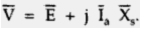
The synchronous motor operates at a leading p.f. indicating that it is delivering reactive power to infinite bus.

Excitation System
Definition: The system which is used for providing the necessary field current to the rotor winding of the synchronous machine, such type of system is called an excitation system.
In other words, excitation system is defined as the system which is used for the production of the flux by passing current in the field winding. The main requirement of an excitation system is reliability under all conditions of service, a simplicity of control, ease of maintenance, stability and fast transient response.
The amount of excitation required depends on the load current, load power factor and speed of the machine. The more excitation is needed in the system when the load current is large, the speed is less, and the power factor of the system becomes lagging.
The excitation system is the single unit in which the each alternator has its exciter in the form of generator. The centralised excitation system has two or more exciter which feeds the bus-bar. The centralised system is very cheap, but the fault in the system adversely affects the alternators in the power plant.

Types of Excitation System
The excitation system is mainly classified into three types. They are
- DC Excitation System
- AC Excitation System
  - Rotor Excitation System
  - Brushless Excitation System
- Static Excitation System
Their types are explained below in details.

DC Excitation System
The DC excitation system has two exciters – the main exciter and a pilot exciter. The exciter output is adjusted by an automatic voltage regulator (AVR) for controlling the output terminal voltage of the alternator. The current transformer input to the AVR ensures limiting of the alternator current during a fault.
When the field breaker is open, the field discharge resistor is connected across the field winding so as to dissipate the stored energy in the field winding which is highly inductive.
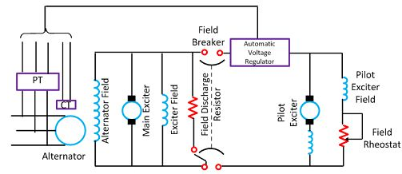
Figure 4.2. DC excitation system

The main and the pilot exciters can be driven either by the main shaft or separately driven by the motor. Direct driven exciters are usually preferred as these preserve the unit system of operation, and the excitation is not excited by external disturbances.
The voltage rating of the main exciter is about 400 V, and its capacity is about 0.5% of the capacity of the alternator. Troubles in the exciters of turbo alternator are quite frequent because of their high speed and as such separate motor driven exciters are provided as standby exciter.

AC Excitation System
The AC excitation system consists of an alternator and thyristor rectifier bridge directly connected to the main alternator shaft. The main exciter may either be self-excited or separately excited. The AC excitation system may be broadly classified into two categories which are explained below in details.

a. Rotating Thyristor Excitation System
The rotor excitation system is shown in the fig. 4.3 below. The rotating portion is being enclosed by the dashed line. This system consists an AC exciter, stationary field and a rotating armature. The output of the exciter is rectified by a full wave thyristor bridge rectifier circuit and is supplied to the main alternator field winding.
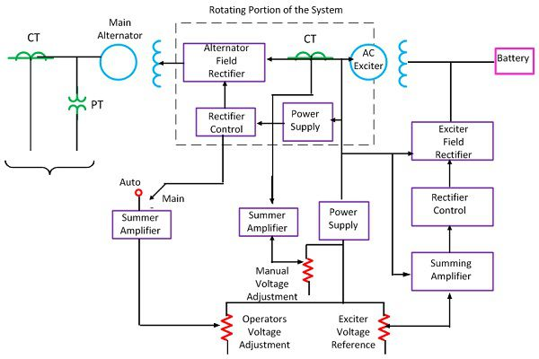
Figure 4.3 Rotating Thyristor Excitation System
The alternator field winding is also supplied through another rectifier circuit. The exciter voltage can be built up by using it residual flux. The power supply and rectifier control generate the controlled triggering signal. The alternator voltage signal is averaged and compare directly with the operator voltage adjustment in the auto mode of operation. In the manual mode of operation, the excitation current of the alternator is compared with a separate manual voltage adjustment.

b. Brushless Excitation System
This system is shown in the fig. 4.4 below. The rotating portion being enclosed by a dashed line rectangle. The brushless excitation system consists an alternator, rectifier, main exciter and a permanent magnet generator alternator. The main and the pilot exciter are driven by the main shaft. The main exciter has a stationary field and a rotating armature directly connected, through the silicon rectifiers to the field of the main alternators.
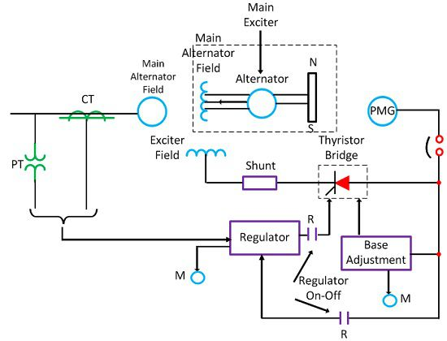
Figure 4.4 Brushless Excitation System
The pilot exciter is the shaft driven permanent magnet generator having rotating permanent magnets attached to the shaft and a three phase stationary armature, which feeds the main exciter field through silicon rectifiers, in the field of the main alternator. The pilot exciter is a shaft driven permanent magnetic generator having rotating permanent magnets attached to the shaft and a 3-phase stationary armature, which feeds the main’s exciter through 3-phase full wave phase controlled thyristor bridges.
The system eliminates the use of a commutator, collector and brushes have a short time constant and a response time of fewer than 0.1 seconds. The short time constant has the advantage in improved small signal dynamic performance and facilitates the application of supplementary power system stabilising signals.

c. Static Excitation System
In this system, the supply is taken from the alternator itself through a 3-phase star/delta connected step-down transformer. The primary of the transformer is connected to the alternator bus and their secondary supplies power to the rectifier and also feed power to the grid control circuit and other electrical equipment.
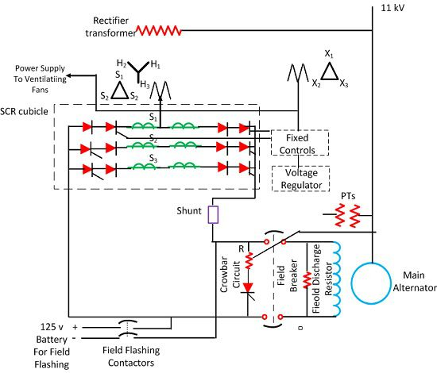

Figure 4.5 Static Excitation System
This system has a very small response time and provides excellent dynamic performance. This system reduced the operating cost by eliminating the exciter windage loss and winding maintenance.

